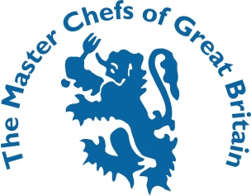
YOUNG PASTRY CHEF OF THE YEAR 2020
The David Lyell Scholarship
The competition is open to any pastry chef aged 23 years and under on the 1st March 2020. The Candidate should be actively working in a hotel a restaurant kitchen, banqueting, college student or within any corporate/event catering environment.
All entries to Sue McGeever masterchefs@msn.com 4th February 2020
The Semi - Finalists of The Young Pastry Chef of the Year will be notified by the 11th February 2020- they will take place on the 3rd March 2020 - Glasgow College - Sheffield College and Town and Country's development Kitchen in Slough

The final will be on Tuesday 7th April 2020 at The Claire Clark Academy - Milton Keynes College.

NAME ___________________________________________________________________________

DATE OF BIRTH ___________________________________________________________________

ESTABLISHMENT __________________________________________________________________

________________________________________________________________________________

JACKET SIZE ________________ (UK inches / EURO cms)
(please circle as appropriate)

I confirm that the recipes I am submitting are my own work.

Signed: __________________________________________________________________________

I, _______________________________________, the undersigned Head Chef/Lecturer fully support my chef’s entry.

Signed: __________________________________________________________________________

Proprietor/Head Chef / Department signature: (if different from the above)

Signed: __________________________________________________________________________

By signing this form, you agree to allow the applicant to participate in this competition and any promotional activities associated with receiving any awards and shall be limited to a maximum of two days activity.
Send your completed entry form together with dish names, recipes, methods, timings and costings to Shaune Hall shaune.hall001@gmail.com

The Master Chefs of Great Britain, Woodmans, Brithem Bottom, Cullompton, Devon EX15 1NB
Tel: 01884 35104 Email: masterchefs@msn.com Website: www.masterchefsgb.co.uk

