Pumpkin Lasagna with Marinated Avocado

Recipe and photo credit: World Avocado Organization

Ingredients
2 avocados
8 tbsp avocado oil
800 g pumpkin, in 1 cm cubes
3 garlic cloves
6 basil sprigs
1.4 litre tomato passata
250 g lasagna sheets
1 vegan mozzarella ball (125 g)
Zest and juice of 1 lemon
Dried chilli flakes, to taste

Equipment
Baking sheet lined with baking paper
Ovenproof dish (30 x 20 cm)

Method
- Preheat the oven to 220ºC. Toss the pumpkin cubes with 2 tablespoons of avocado oil and spread them out over the baking sheet. Roast the pumpkin cubes in the preheated oven for about 20 minutes.
- Finely chop the garlic and the leaves of 4 basil sprigs. Heat 2 tablespoons of avocado oil in a frying pan. Sauté the garlic with the finely chopped basil for 1 minute.
- Add the passata and bring to a boil. Turn the heat down to low and simmer for 10 minutes.
- Take the pumpkin cubes out of the oven. Lower the oven temperature to 200ºC.
- Spoon a layer of tomato sauce into the ovenproof dish and cover with lasagna sheets. Add the roasted pumpkin cubes to the rest of the tomato sauce. Season with salt and pepper.
- In the ovenproof dish, make more layers with the lasagna sheets and the pumpkin sauce. Finish with a layer of sauce. Tear the vegan mozzarella into pieces and divide over the lasagna.
- Bake the lasagna in the preheated oven for about 25 minutes until golden brown and done.
- Halve the avocados, remove the stones and peel off the skin. Dice the avocado. Mix the avocado cubes with the lemon zest, the lemon juice and 4 tablespoons of avocado oil. Add chilli flakes to taste.
- Take the lasagna out of the oven. Top with the marinated avocado and the leaves of the last 2 sprigs of basil.

Recipe Tip
Top the lasagna with marinated avocado with some coarsely chopped and roasted hazelnuts for an extra autumnal touch.

Sweet Chilli Noodles with Avocado Tempura

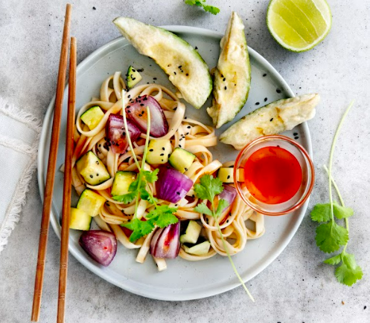
Recipe and photo credit: World Avocado Organization

Ingredients
2 avocados
2 tbsp of avocado oil
1 courgette
3 red onions
300 g noodles, e.g. udon noodles
Frying oil
125 g flour
25 g cornflour
6 tbsp Thai sweet chilli sauce + extra for dipping
Juice of 2 limes
8 coriander sprigs
1 teaspoon (black) sesame seeds

Method
- Dice the courgette into 1 cm cubes. Dice the onions into 1 cm pieces.
Cook the noodles according to the instructions on the package in plenty of salted water. Heat the oil for frying to 180ºC.
- In a bowl, mix the flour, cornflour, ½ teaspoon of salt and about 200 ml of ice-cold water until the batter has the thickness of full-fat yoghurt. Do not overmix, it should be a little lumpy.
- Halve the avocados, remove the stones and peel off the skin. Cut the avocado into wedges.
- Dip the avocado wedges into the batter in 3-4 batches until coated and gently slide them into the hot oil. Fry the avocado for 2-3 minutes until crispy. Drain the avocado tempura on a paper towel and fry the next batch.
- Meanwhile, heat a wok. Add the avocado oil. Stir fry the courgette and onion for 3 minutes.
- Add the noodles, chilli sauce, and lime juice to the wok and stir fry for another minute.
- Divide the noodles over 4 plates or bowls and add the avocado tempura. Garnish with coriander and sesame seeds. Serve with extra chilli sauce for dipping.

Recipe Tip
Serve extra lime wedges with the avocado tempura.

